**CREATE APP in developer console
Dropbox
Create new app in https://www.dropbox.com/developers/apps and get App_id, App_secret
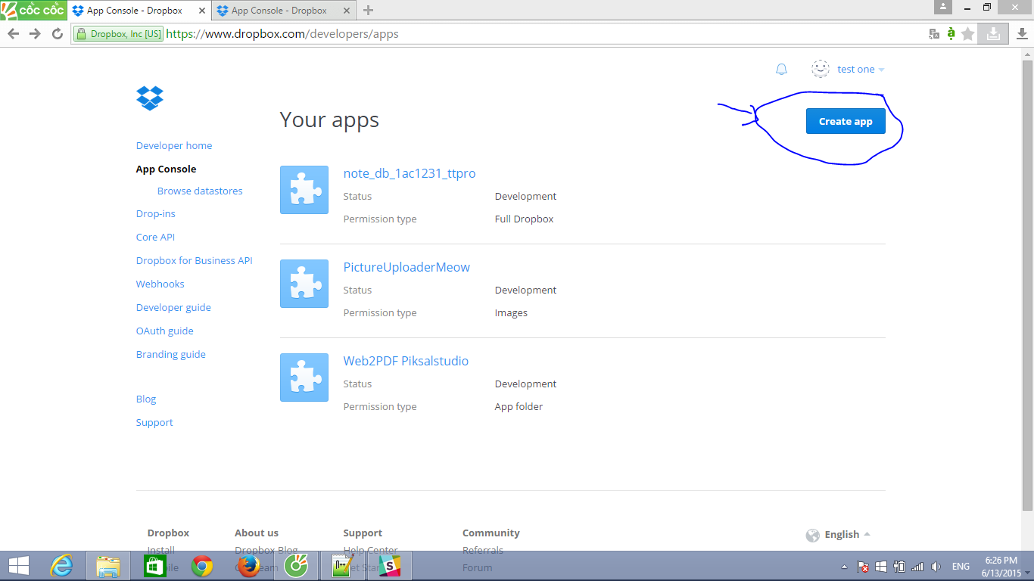
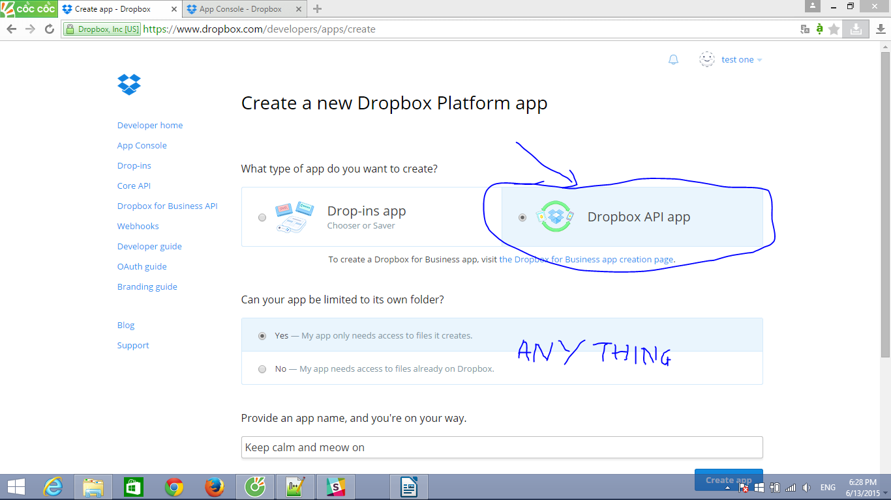

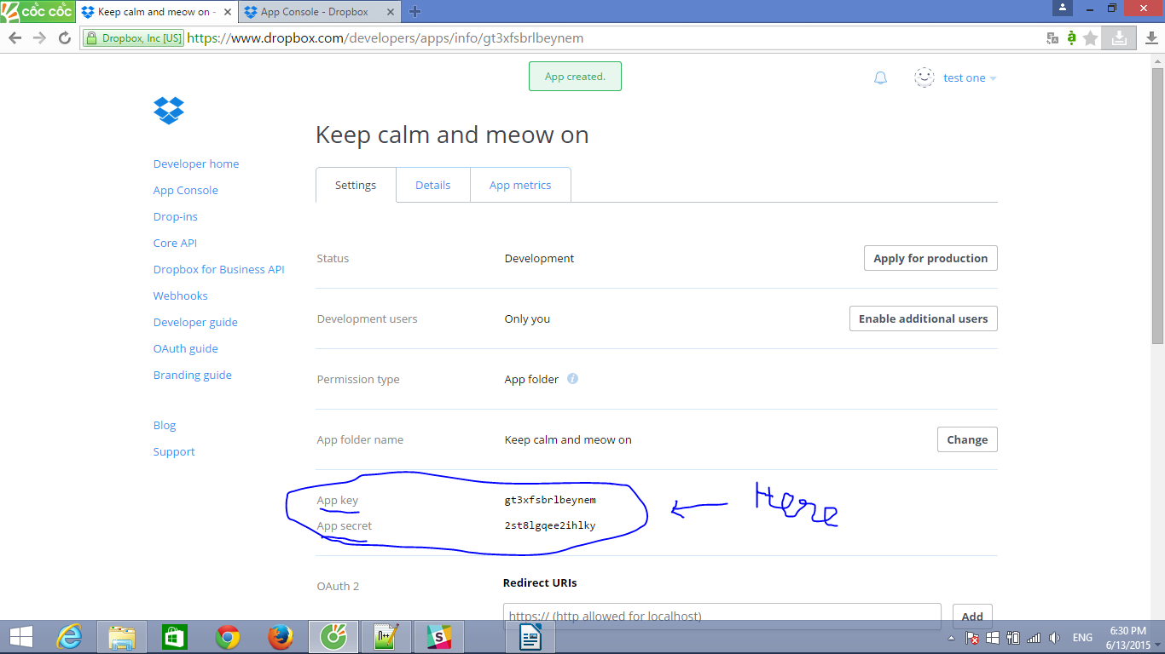
Save App key and App secret somewhere. You will need it.

Google Drive
Go to https://console.developers.google.com/project and create project
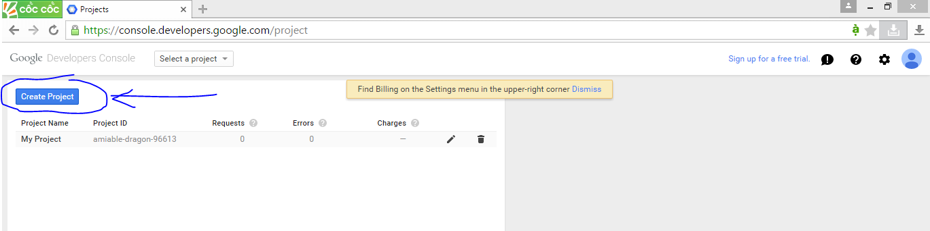
Enter project name
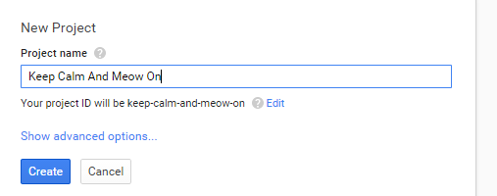

Wait until project is created.

Then go to APIs & auth/APIs, Drive Api
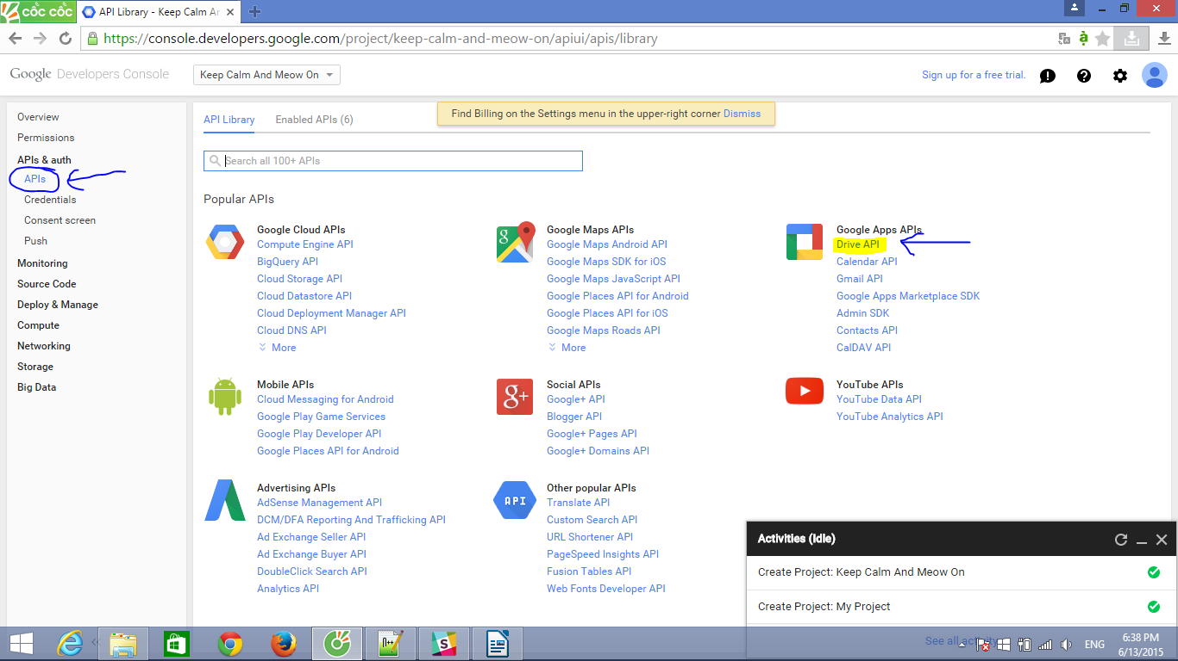
Enable API
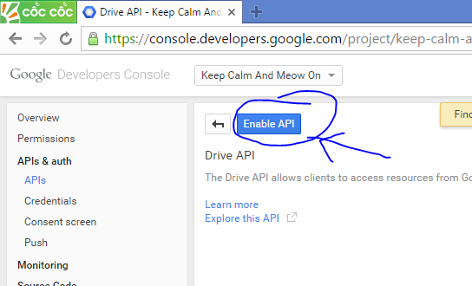

APIs & auth/ Credential and create new Client ID

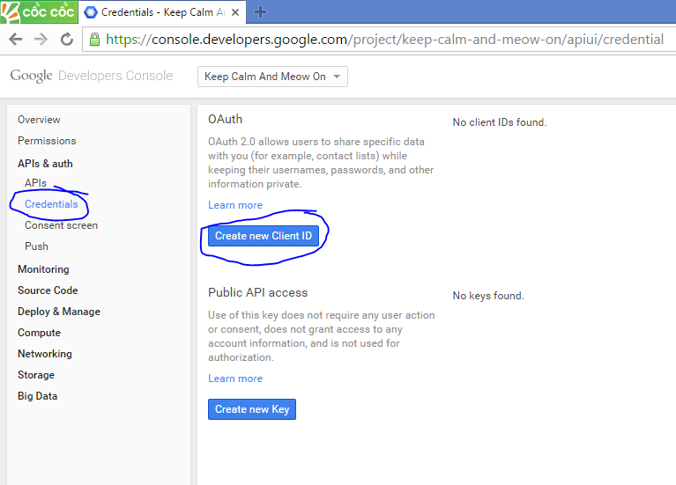
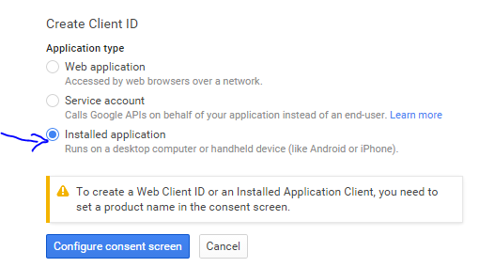

Fill in information about your app then click save
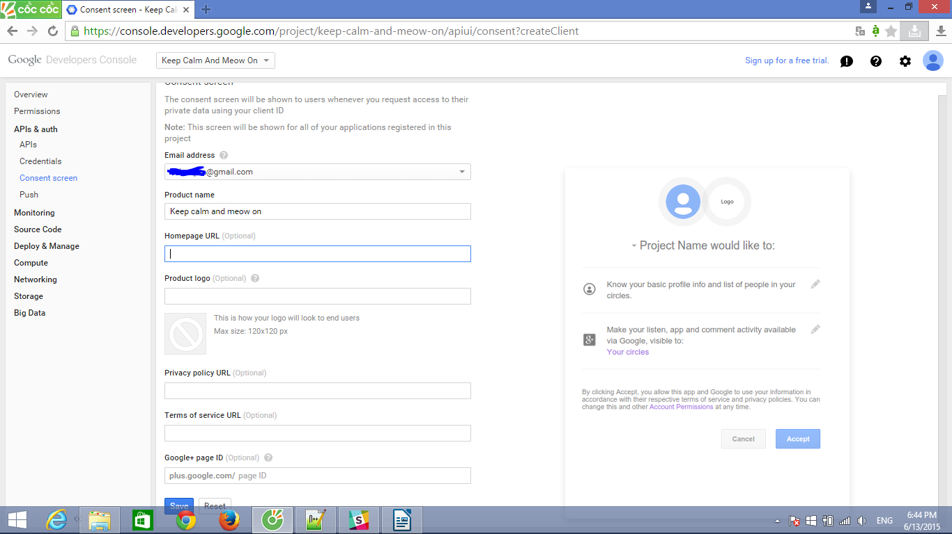
Now it is time to get SHA1 of your .keystore
+ find your debug.keystore
(debug.keystore is usually in "C:\Users\Your_User_Name\.android\debug.keystore")
+open CMD
+ navigate to C:\Program Files\Java\jdk1.8.0_45\bin
+ run command
keytool -exportcert -alias androiddebugkey -keystore "C:\Users\Thien\.android\debug.keystore" -list -v
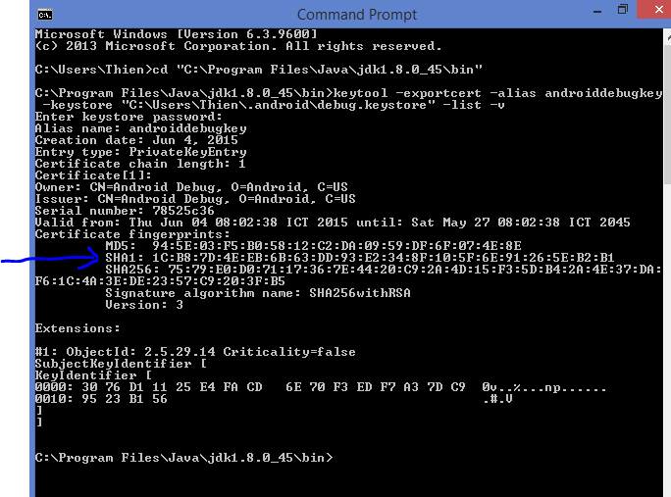
+enter password: android
+ copy your SHA1

+ Now fill in Create Client ID form
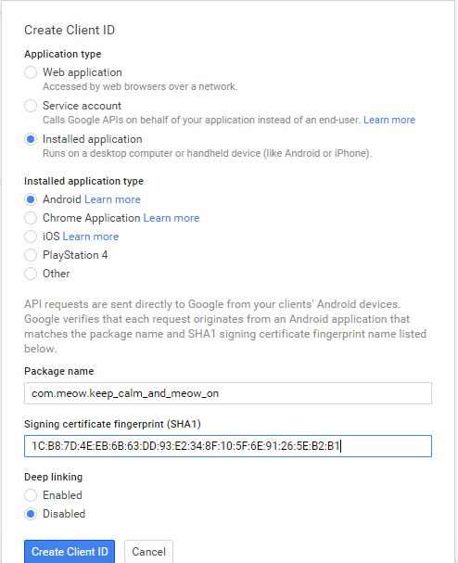

Save client id somewhere. You will need it.
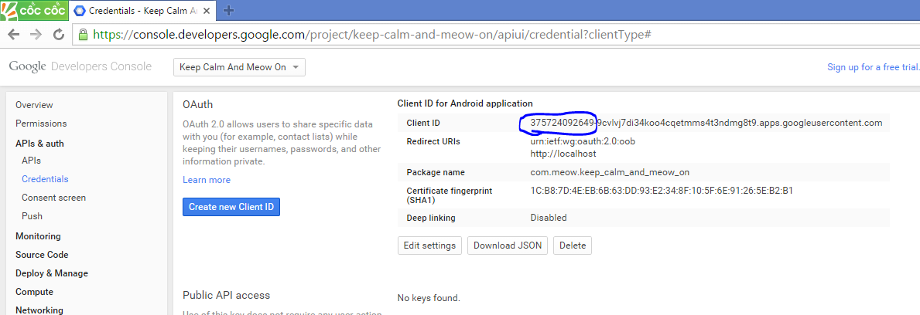

IMPORT MODULE TO PROJECT
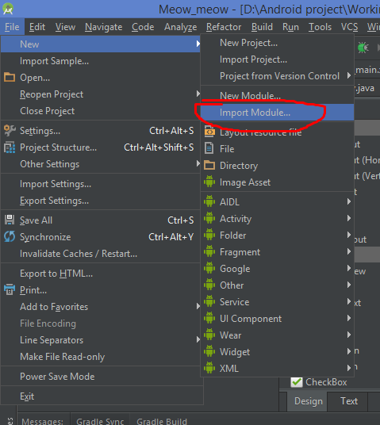
Import module

From ...\PictureUploader2\clouduploader
Wait android studio import for you. It take about 1 to 5 minutes.
You will see like this
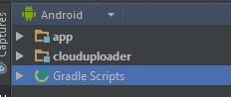

Next, we need to add dependency for you app.
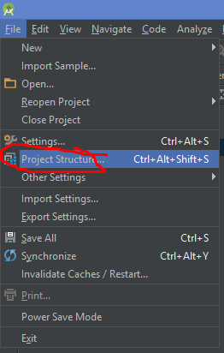
File → Project Structure

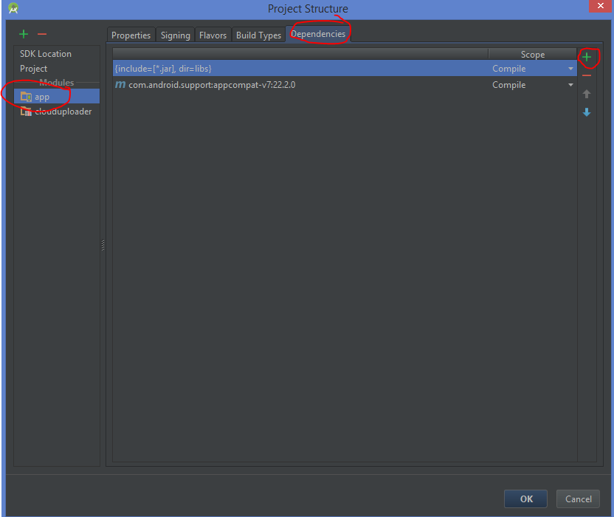
In project Structure form.
On Modules (left panel), choose “app”. Then choose tag Dependencies. Then click “+”

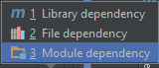

Choose Module dependency

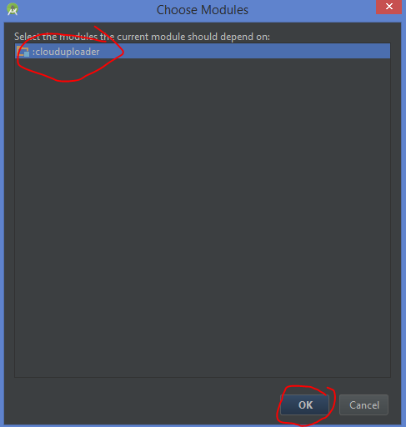
Choose clouduploader and click ok.

Wait a bit for android studio to work for you.
Now you are done import clouduploader to your project.

SET UP DROPBOX AND GOOGLE DRIVE IN YOUR PROJECT

In manifest, add some permission.
<uses-permission android:name="android.permission.INTERNET" />
<uses-permission android:name="android.permission.READ_EXTERNAL_STORAGE" />
<uses-permission android:name="android.permission.GET_ACCOUNTS" />
Add login activity, for both dropbox and google drive
<activity
android:name="com.PiksalStudio.thien.clouduploader.LoginActivity"
android:label="@string/title_activity_login"
android:parentActivityName=".MainActivity" >
<meta-data
android:name="com.google.android.apps.drive.APP_ID"
android:value="id=1025765906493" />
<intent-filter>
<action android:name="com.google.android.apps.drive.DRIVE_OPEN" />
<data android:mimeType="application/vnd.google-apps.drive-sdk.1025765906493" />
<data android:mimeType="image/png" />
<data android:mimeType="image/jpeg" />
<data android:mimeType="image/jpg" />
</intent-filter>
</activity>
Replace 1025765906493 with your google client ID

Add dropbox activity
<activity
android:name="com.dropbox.client2.android.AuthActivity"
android:configChanges="orientation|keyboard"
android:launchMode="singleTask" >
<intent-filter>
<!-- Change this to be db- followed by your app key -->
<data android:scheme="db-gg5bv3ify8ok6td" />
<action android:name="android.intent.action.VIEW" />
<category android:name="android.intent.category.BROWSABLE" />
<category android:name="android.intent.category.DEFAULT" />
</intent-filter>
</activity>
Replace gg5bv3ify8ok6td with your app key.
For ever activities that use google drive, add
<meta-data
android:name="com.google.android.apps.drive.APP_ID"
android:value="id=1025765906493" />
and
<intent-filter>
<action android:name="com.google.android.apps.drive.DRIVE_OPEN" />
<data android:mimeType="application/vnd.google-apps.drive-sdk.1025765906493" />
<data android:mimeType="image/png" />
<data android:mimeType="image/jpeg" />
<data android:mimeType="image/jpg" />
</intent-filter>
Remember to replace 1025765906493 with your google client ID.
Initialize clouduploader by call it public constructor.
public CloudUploader( Activity activity, String APP_FOLDER_NAME, String Dropbox_app_id, String Dropbox_app_secret)
Activity: the current activity, which we initialize clouduploader. (ex: My_Activity.class)
APP_FOLDER_NAME: folder with file will be upload to. (ex: my_picture)
Dropbox_app_id and Dropbox_app_secret : Dropbox app key and dropbox app secret we already got from app console.

LOGIN
public void StartLoginActivity()
It will start Login Activity, which allow user to login dropbox and google drive. Call it after constructor. But you may only need to call it once for whole app, not every instance of CloudUploader, because login token are saved in SharedPreference.
You can customize layout in CloudUploader module.
"%\PictureUploader2\clouduploader\src\main\res\layout\activity_login.xml"

Upload To Dropbox
public void UploadFileDropbox(String Name, InputStream is, Long Length )
Name: name of file you want to store on dropbox. Including extension (ex: my_avata.png)
is: InputStream of file
Length: size of file.
File will be upload into folder named we have defined in APP_FOLDER_NAME

Upload To Google Drive
public void UploadFileGoogleDrive(String Name, InputStream is, Long Length )
Name: name of file you want to store on dropbox. Including extension (ex: my_avata.png)
is: InputStream of file
Length: size of file.
File will be upload into folder named we have defined in APP_FOLDER_NAME

GET EXAMPLE AND MODULE HERE
https://github.com/ttpro1995/PictureUploader2

